
Sukkur Institute of Business Administration University
Department of Computer Science
ESE-201: Digital Logic Design Lab

Lab # 03: X-OR & X-NOR Gates

Note: Submit this lab hand-out in the next lab with attached solved activities and exercises

Submission Profile
Name: Majid Ali Submission date (24/08/2026):
Marks obtained: Receiving authority name and signature:
Comments:
________________________________________________________________________________
Instructor Signature
Lab Learning Objectives:

Upon successful completion of this experiment, the student will be able:
- To implement and verify X-OR gate operations using 74LS86 IC & Module KL-33001
- To implement and verify X-NOR gate operations using 74LS266 IC & Module KL-33001

Lab Hardware and Software Required:
- 74LS86 IC (X-OR gate )
- 74LS266 IC(X-NOR gate)
- Module KL-33001
- Breadboard
- Connecting Wires

Background Theory:

X-OR gate:
Exclusive OR gate, commonly abbreviated as X-OR is a special type of OR gate. Logic symbol for the XOR gate is shown in Fig 3.1 (a & b). The output of an X-OR is high only when the two inputs are at opposite logic levels. Alternatively, X-OR gate provides a high output if one input or the other is high, but not both. The X-OR gate has only two inputs. Unlike the other gates, it never has more than two inputs. The X-OR output expression is written as X=AB, where the symbol” ” represented X-OR operation.
X=A⊕B
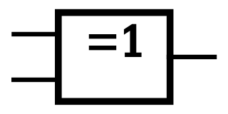

X=A⊕B
A
A
B
B

Fig 3.1: (a) Distinctive symbol of X-OR gate (b) Standard X-OR gate symbol
74LS86 2-Input X-OR gate IC:
In order to implement the X-OR operation using IC, the TTL 74LS86 2-input X-OR gate IC can be used. This IC has 14 pin Dual Inline Package (DIP) configuration as shown in fig 3.2. The power supply connections are made to pin 7 and 14. Pin 1 is identified by a small indented circle next to it or by a notch cut out between pin 1 and 14.
Fig 3.2: 74LS86 2-input X-OR gate IC pin configuration
X-NOR gate
Exclusive NOR (abbreviated as X-NOR) is the complement of X-OR, like the X-OR gate, the X-NOR gate has only two inputs. The logic symbol for X-NOR gate is shown in Fig 3.3 (a & b).
The characteristics of X-NOR will be completely opposite of X-OR gate. As in X-OR gate, the same inputs caused low output but here in X-NOR the case is reversed, means on same inputs the output is high.
X=A⊕B
X=A⊕B

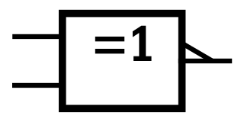
A
A

B
B

Fig 3.3: (a) Distinctive symbol of 2-input X-NOR gate(b) Standard 2-input X-NOR gate symbol
74LS266 2-input X-NOR gate IC:
In order to implement the NOR gate operation using IC, the TTL 74LS266 2-input X-NOR gate IC can be used. This IC has 14 pin Dual Inline Package (DIP) configuration as shown in Fig 3.4. The power supply connections are made to pin 7 and 14. Pin 1 is identified by a small indented circle next to it or by a notch cut out between pin 1 and 14.
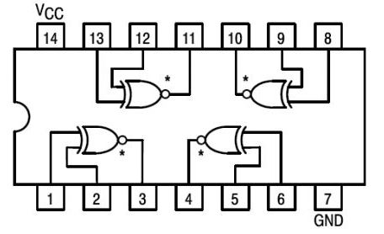
Fig 3.4: 74LS266 2-input X-NOR gate IC pin configuration
Lab Examples:
- Implementation of X-OR gate also Implement this into Multisim/TinkerCad.

- In order to implement the X-OR gate operations with the help of ICs, take the 74LS86
- Pin Assignments for the ICs have been shown in Fig 3.2
- Take 74LS86 IC and insert it in the breadboard present on the KL-33001 training kit
- Connect its pin 14 to +5V and pin 7 to ground
- Use first gate (any one can be taken) from IC by connecting input pin 1 & input pin 2 to SW0 & SW1 respectively, and output pin3to LED and observe the AND gate operation
- Fill the following observation table

Input |  | Output
A | B | LED (on / off) | Level ( 1 / 0 )
0 | 0 | 0ff | 0
0 | 1 | on | 1
1 | 0 | on | 1
1 | 1 | off | 1
Table 3.1: Observation table of 2-input X-OR gate
Lab Activities:
- Implementation of X-NOR gate also Implement this into Multisim/TinkerCad.

- In order to implement the X-NOR operations with the help of IC, take the 74LS266 IC
- Pin Assignments for the ICs have been shown in Fig 3.4
- Take 74LS266 IC and insert it in the breadboard present on the KL-33001 training kit
- Connect its pin 14 to +5V and pin 7 to ground
- Use first gate (any one can be taken) from IC by connecting input pin 1 & input pin 2 to SW0 & SW1 respectively, and output pin3to LED and observe the AND gate operation
- Fill the following observation table

Input |  | Output
A | B | LED (on / off) | Level ( 1 / 0 )
0 | 0 | on | 1
0 | 1 | off | 0
1 | 0 | 0ff | 0
1 | 1 | on | 1
Table 3.2: Observation Table of 2-input X-NOR gate

Lab Exercises:
- XOR and XNOR Gate Applications also implement this into Multisim/Tinker Cad.

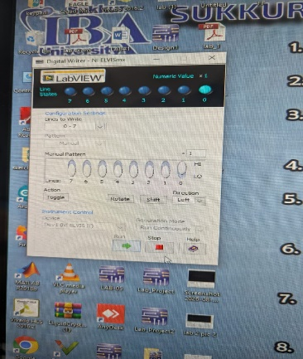
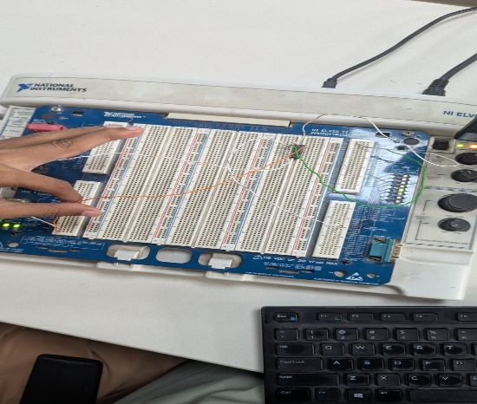
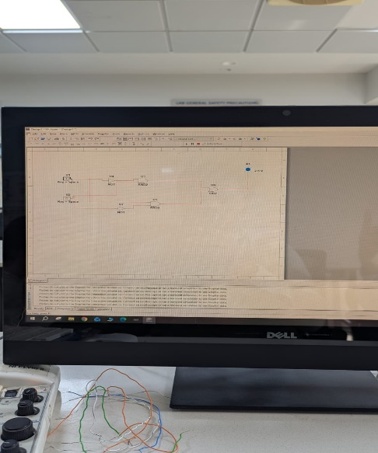
XOR

XNOR
